**OBJECT ORIENTED PROGRAMMING LABORATORY**

**19Z311**



**EXPERIMENT: 2**

**STUDY OF REPL**

**ABINAV P**

**22z201**

**BE CSE G1**

# **READ-EVAL-PRINT LOOP (REPL) IN JAVA**

In Java, "REPL" stands for "Read-Eval-Print Loop." A REPL is an interactive programming environment that allows you to enter and execute individual lines of code or expressions one at a time. It's a tool that is commonly used for quick experimentation, testing, and learning.

Here's how a typical Java REPL session works:

Read: You enter a line of Java code or expression into the REPL.

Eval: The REPL evaluates the code or expression you entered.

Print: The result of the evaluation is displayed in the REPL, typically the result of the expression you entered.

Loop: The REPL returns to the "Read" step, allowing you to enter another line of code or expression. This process continues until you exit the REPL.

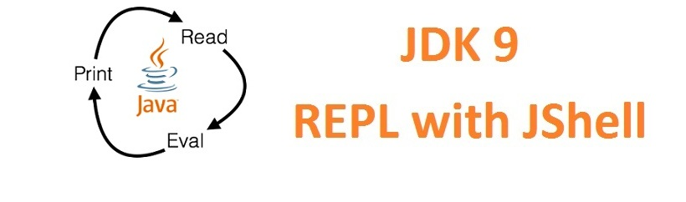

Java doesn't have a built-in REPL like some other programming languages (e.g., Python or JavaScript). However, there are third-party tools and libraries that provide a Java REPL environment. One popular option is "JShell," which is included in the Java Development Kit (JDK) starting from JDK 9. JShell allows you to interactively enter and execute Java code snippets.

To use JShell, you can open your terminal or command prompt and type jshell to start an interactive session. From there, you can enter Java code, evaluate expressions, and see the results interactively. For example:

